Custom SmartVent Thermostat
User Manual
Ted Toal
19-Sep-2023

SmartVent Thermostat Project History
My house Beutler HVAC system included a Beutler SmartVent for whole-house cooling. The SmartVent is a great idea, it pulls in cool summer evening air and blows it out the registers throughout the house, exhausting the return air to the attic and hence outdoors. It lets you cool your house at night with outdoor air in the summer, using only the fan and not the more expensive A/C system.
However, the Beutler HVAC controller (near the furnace) uses specialized digital thermostats that can't be replaced with a traditional thermostat (like a Nest or EcoBee).Besides that problem, our Beutler thermostats started having problems such as inability to maintain the schedule we set. I looked for an alternative to the Beutler thermostats that wouldn’t require replacing the entire HVAC system.I found that I could replace my Beutler controller with an EcoJay controller that allowed me to use standard thermostats. I describe how to replace the controller in my hackster.io project titled Standard thermostats replace Beutler specialized ones! Go there for a full description of how to do that.
Unfortunately, the EcoJay controller and regular thermostats know nothing about how to properly control the SmartVent. I had to leave my SmartVent disconnected. This motivated me to do another project: I designed and built a custom thermostat to control the SmartVent. It is installed along with the regular thermostats (which continue to work as before), and it only controls SmartVent (the SmartVent damper and the HVAC vent fan) and doesn’t do anything with the furnace or A/C. I describe how to build this custom SmartVent thermostat on hackster.io also, in the project titled Build a Beutler SmartVent Custom Thermostat.
This document is the User’s Manual for the SmartVent Custom Thermostat.

Thermostat Basics
The thermostat has no battery, it is powered by the 24VAC wires coming from the HVAC system.

Also, it does not know the time, which means you don’t have to SET the time or change it when daylight savings time happens!

All temperatures are currently in degrees Fahrenheit.

It has a display screen that shows the temperature and settings. The screen is touch-sensitive, and you change settings by tapping it with your finger or with the plastic stylus that comes with it.

There are several different screens, the Main Screen and some settings screens. Almost always, you will display and use the Main Screen. Rarely, you will access the Settings Screen to change settings. You probably won’t use the other screens.

The display is normally dark. It lights up when you touch it, so you can read it. After it lights up, if you don’t touch it for around 45 seconds, it goes dark, and you have to touch it again to read it.

The Main Screen is identified by the word SmartVent in red and blue at the top. The other screens are identified by the screen name at the top, which is one of:
- Settings - the basic settings screen
- Cleaning - the screen to use when you want to clean the screen by wiping it with something
- Advanced - the advanced settings screen
- Special - the special settings screen
- Calibrate - the touch calibration screen
- Debug - a special screen for DIYer’s who want to work on the thermostat itself

There are two lights that shine through the vents of the thermostat. The red light shines to indicate the thermostat is on and has power. The pink light shines to indicate that SmartVent cooling is on.

All screens have buttons on them that you can tap to change settings or to switch screens. Most buttons are rectangular in shape and have a pinkish background with a black outline. Some buttons are small triangles, used to change numeric values.

Next is a Quick Start section, which is probably the only thing you need to read. Following that, there is one section for each screen. Each has one or more photos to show the screen layout.

Quick Start
You will usually view the thermostat’s Main Screen (Figure 1). Besides showing the indoor and outdoor temperatures, there are only 3 things you need to know about it.

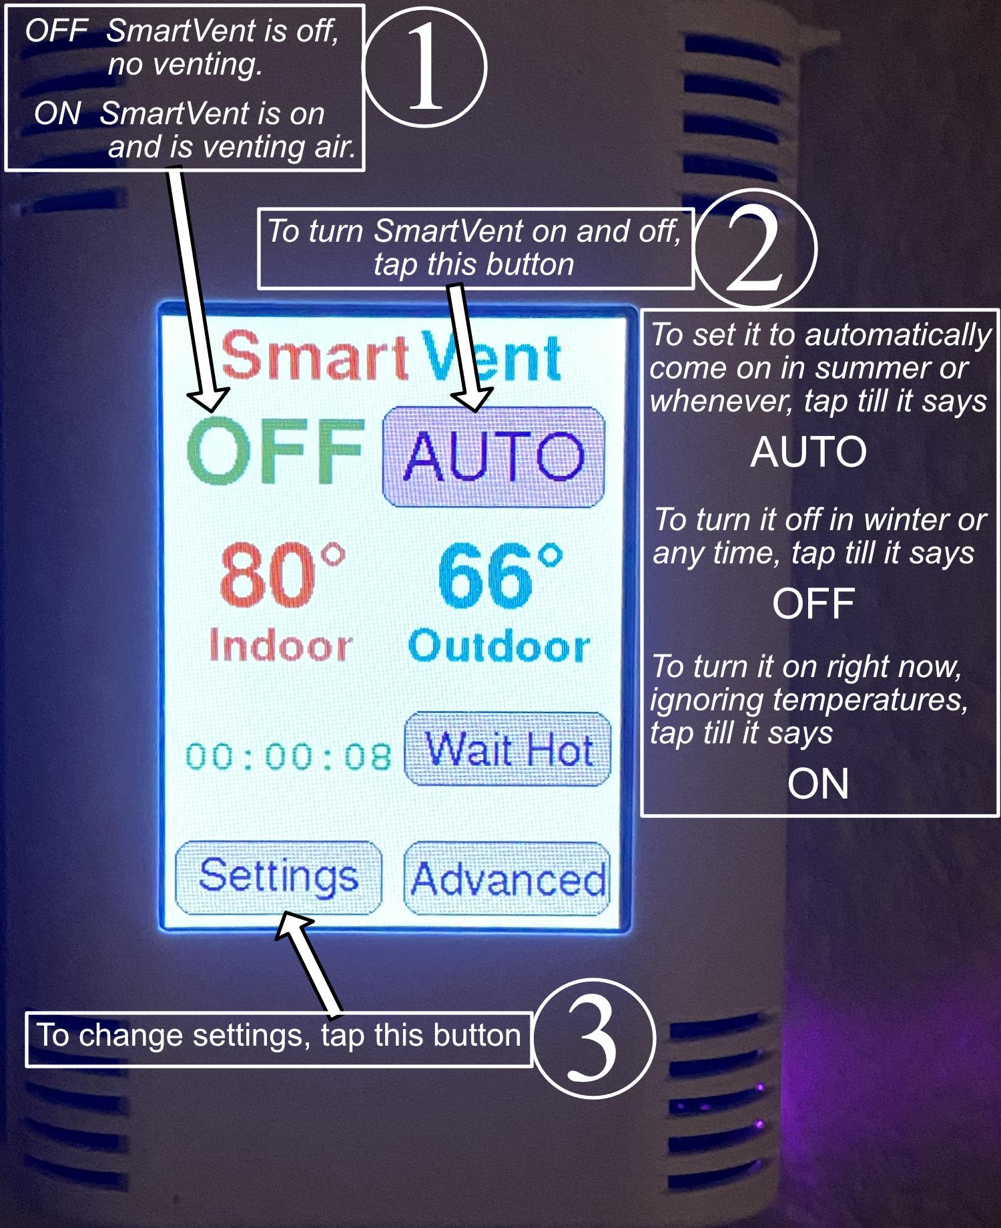
Figure 1: The 3 things you need to know on the Main Screen

Tapping the Settings button takes you to the Settings Screen (Figure 2).

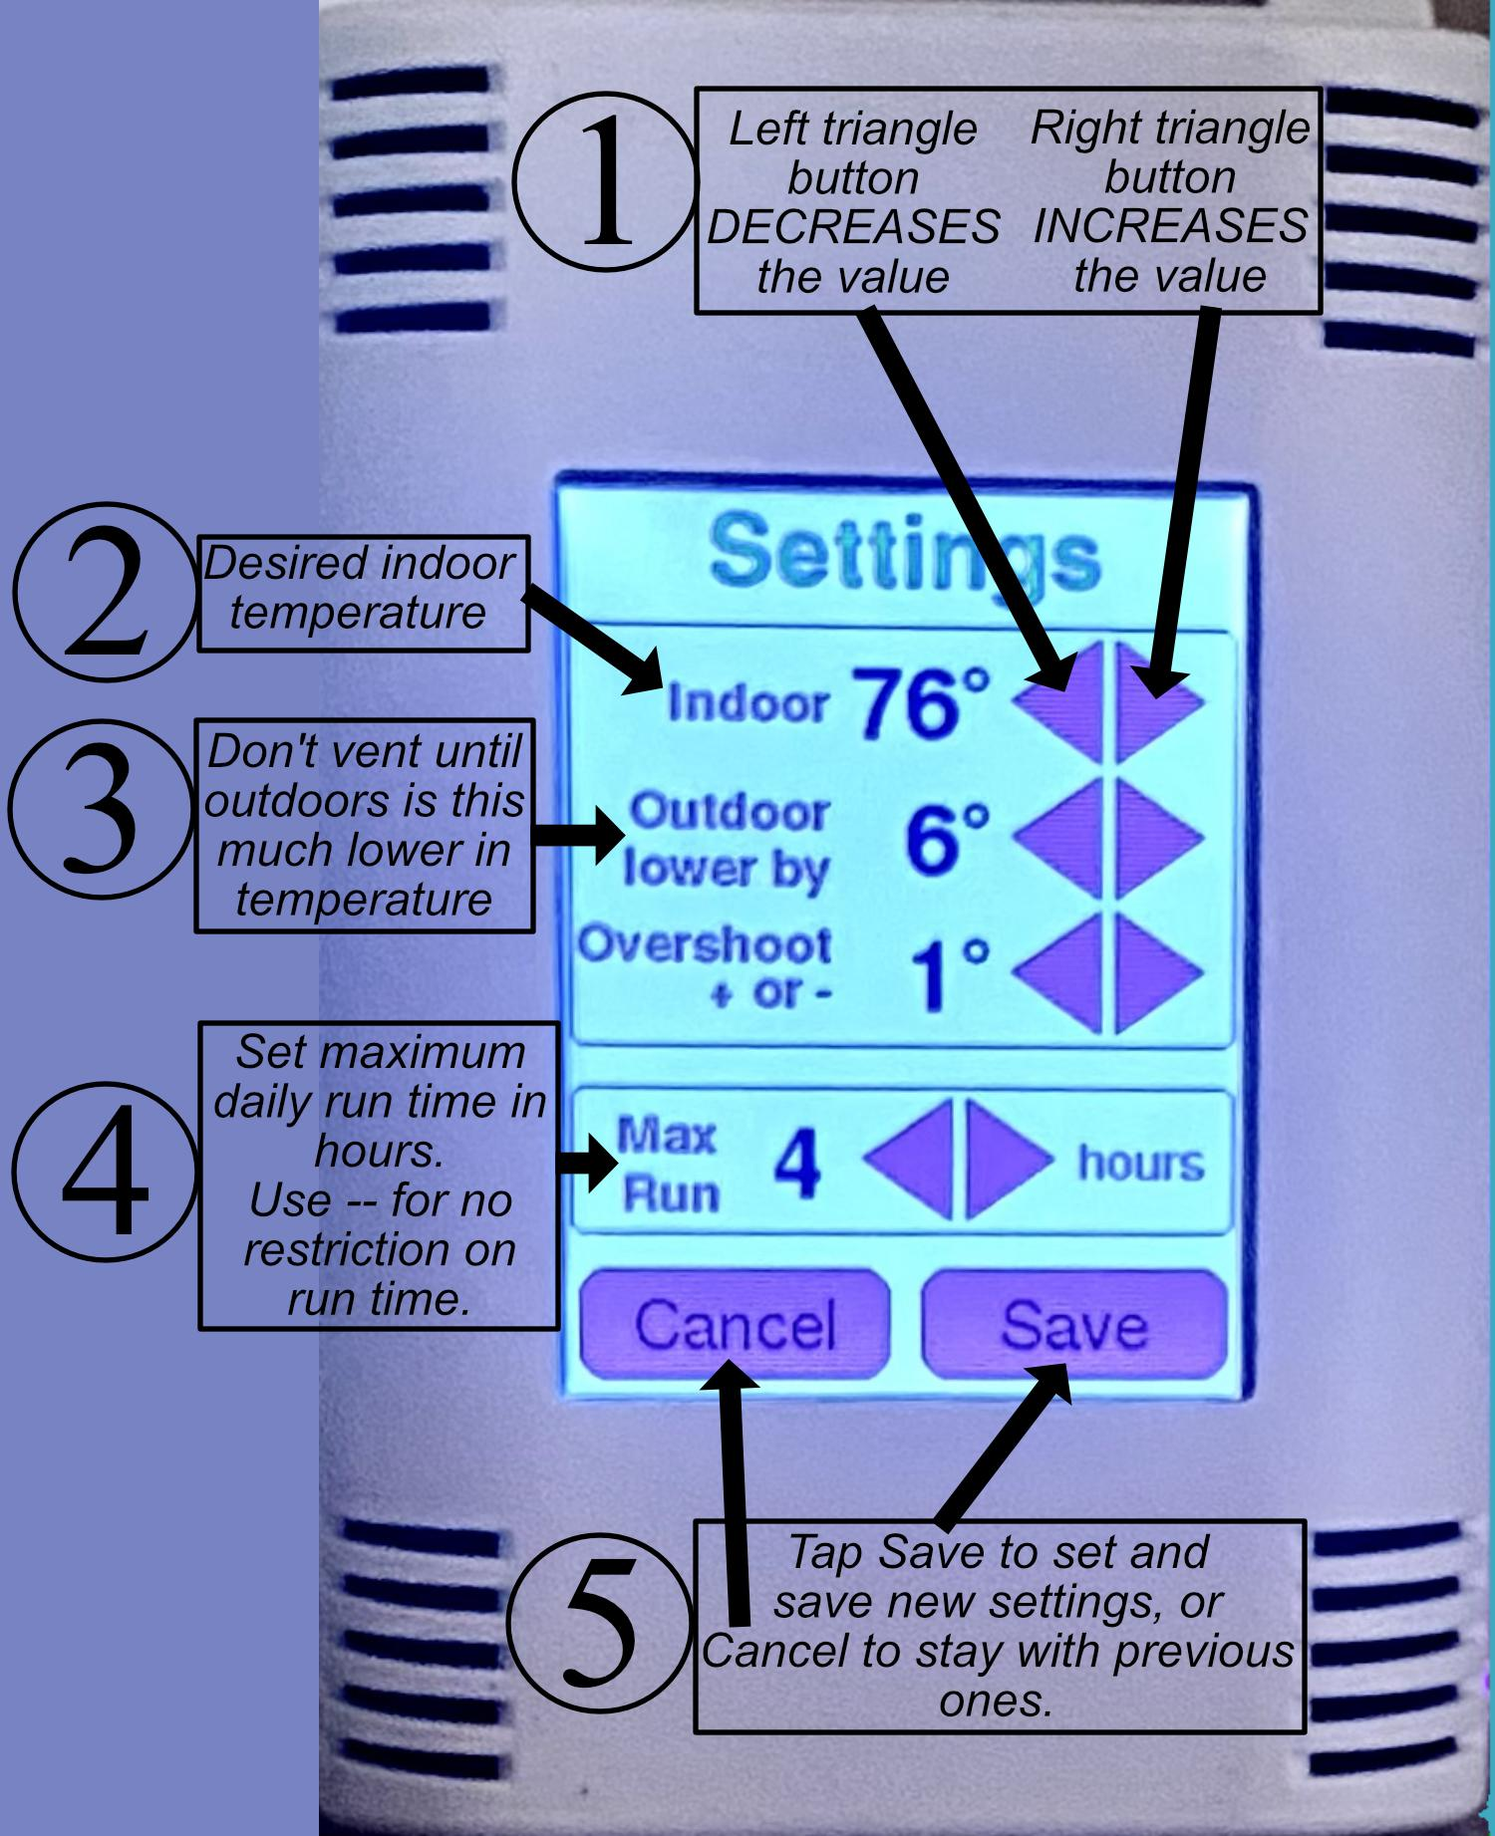
Figure 2: The 5 things you need to know on the Settings Screen

Main Screen
The Main Screen (Figure 3) says SmartVent at the top in red and blue.

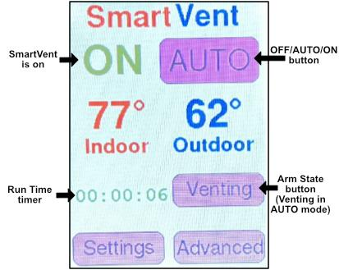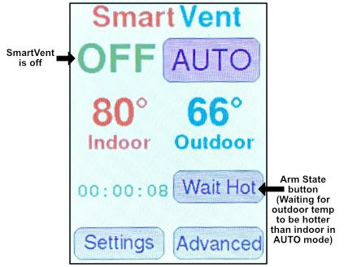
Figure 3: Two views of the Main Screen

The indoor temperature is on the left side in red and the outdoor temperature is on the right side in blue. (The indoor temperature is at the thermostat itself, while the outdoor temperature is at wherever the outdoor temperature sensor is located, perhaps attached to the outdoor A/C compressor).

At the bottom of the Main Screen are two buttons labeled Settings and Advanced. If tapped, these take you to the corresponding screens to change settings. The Settings screen is the one you will use occasionally. You may never need to use the Advanced screen.

Above the indoor temperature will be the word OFF or ON. This indicates whether SmartVent cooling is currently on or off. In the AUTO and ON settings SmartVent can be ON or OFF (if the maximum run time has expired or if the temperature conditions are not yet right).

Above the outdoor temperature is a Mode button that you use to turn SmartVent on and off. Its label cycles through these values each time you tap it:
- OFF - SmartVent is off and will not turn on
- AUTO - SmartVent is in auto mode and will turn on when temperature conditions are right
- ON - SmartVent is on manually and will stay on until turned off or until a set run time expires

Typically you will set it to AUTO in the summertime and OFF most other times. When you tap the Mode button, the setting does not take effect immediately. You need to stop touching the screen for about 15 seconds before the new settings take effect. If you accidentally tap the button and don’t want that setting, just tap it again until the desired setting shows.

Underneath the indoor temperature, the Run Timer appears in the AUTO or ON mode setting. It shows the current total venting run time, which counts up while SmartVent is on, up to the maximum run time setting, at which time SmartVent is turned off. Use the Settings Screen to set or disable the maximum run time.

Underneath the outdoor temperature, an Arm button appears in the AUTO or ON mode setting, and its label tells you if the thermostat is armed or not, as follows.

In AUTO mode, the Arm button label is one of these:
- Wait On - thermostat is waiting for temperature conditions to be right to turn SmartVent on
- Venting - SmartVent cooling is on
- Wait Hot - SmartVent was on until the run timer timed out, and is now off and waiting till it is hotter outdoors than indoors before clearing the run timer and returning to Wait On (used only if maximum run time has been enabled)

In ON mode, the Arm button label is one of these:
- Venting - SmartVent cooling is on
- Timeout - SmartVent was on until the run timer timed out, and is now off. Tap the Timeout button to clear the run timer and turn it back on again.

In the AUTO setting, tapping either Wait On or Venting turns off SmartVent and switches to the Wait Hot arm state (it won’t come on again until after it has gotten hot outdoors or you tap it again), while tapping Wait Hot clears the run timer and switches to the Wait On arm state (it will come on again when the temperature conditions are right).

In the ON setting, tapping either the Venting or Timeout button resets the run timer and turns on SmartVent if it was off.

In the AUTO setting, if the run timer has expired and SmartVent has turned off and entered Wait Hot, but you want it to go back on again, you could do any of these:
- Tap Wait Hot
- Tap AUTO three times to go to ON, OFF, and back to AUTO, clearing the run timer
- Tap Settings and increase the maximum run time

Again in the AUTO setting, if SmartVent has turned off because the indoor temperature has reached your temperature setpoint, but you want to turn it back on again, you should tap Settings and decrease the Indoor temperature setpoint. (Or, you could tap AUTO to change it to ON).

Again in the AUTO setting, if SmartVent has turned off because the outdoor temperature is too close to the indoor temperature, but you want to turn it back on again, you should tap Settings and decrease the Outdoor Lower by setting. (Or again, you could tap AUTO to change it to ON).

Finally, if in the AUTO setting you find that SmartVent is turning on and off too often, you should tap Settings and increase the Overshoot + or - setting. If instead you find that SmartVent is going too far past the temperature setpoints before turning on or off, decrease the Overshoot + or - setting.

It can be difficult to get the settings to work exactly as you want all the time. Ideas for improvements to the way the thermostat works are certainly welcome!

Settings Screen
Tapping the Settings button on the Main Screen takes you to the Settings Screen (Figure 4), which is where the main settings for SmartVent are found.

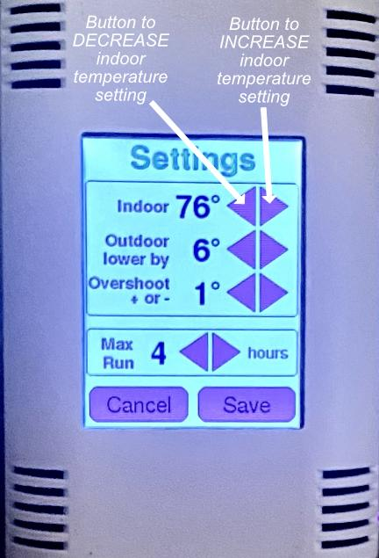
Figure 4: The Settings Screen with arrows pointing to buttons to change Indoor setting

These settings take on reasonable initial values, but you can change them and save the changed settings so they become permanent. The four settings are:
- Indoor - desired indoor temperature to achieve using SmartVent cooling, the indoor “setpoint”.
- Outdoor lower by - the outdoor temperature must be lower than the indoor temperature by this many degrees or more in order to turn on SmartVent. If this value is too small, you may find that you are wasting energy turning on SmartVent when it can’t really cool much because the outdoor temperature is not that much cooler. If this value is too large, you may find that SmartVent doesn’t turn on until late into the night, and doesn’t have a chance to do as much cooling as it otherwise might.
- Overshoot + or - - both of the above settings have this amount of “wiggle room”, used to prevent SmartVent from turning off and on too frequently. See detailed explanation below.
- Max Run - the maximum number of hours that SmartVent is allowed to run before timing out and turning off. If set to 0, the display shows “–” and the run timer is disabled. You only need to set this to a non-zero value if you want to limit the run time. Often you won’t care and will leave the setting at “--” so it runs as long as it is able to continue cooling.

To change any setting, tap the triangular buttons to its right. The left-pointing triangle lowers the value and the right-pointing triangle raises it.

When finished, tap the Save button at the bottom to save the settings and make them permanent. Or, tap the Cancel button to discard your changes. Either button then returns you to the Main Screen.

Explanation of Overshoot + or -
Sometimes it may appear that the thermostat is not honoring the Indoor and the Outdoor lower by settings. The likely reason has to do with the Overshoot + or - setting. This is easiest to explain with an example. Suppose the Indoor setting is 76°, and suppose the house cools to that temperature and SmartVent turns off. Then, suppose the temperature rises to 76.1°. SmartVent would turn on again, since the temperature is now higher than the setting. You can see how SmartVent might turn off and on rather often. This is especially likely because the house walls hold heat, and after SmartVent turns off, they tend to warm the room air again pretty quickly. The purpose of the Overshoot + or - setting is to avoid this rapid on/off cycling of SmartVent. The way it works is that the Indoor setting is altered by adding or subtracting the Overshoot + or - setting. Suppose Overshoot + or - is set to 2°. Then the Indoor setting is modified into two values, 76-2=74° and 76+2=78°. The house must cool to the lower value of 74° before SmartVent is turned off, and then it must warm to the higher value of 78° before SmartVent turns on again. That greatly reduces rapid on/off cycling. The higher the value you set for Overshoot + or -, the less cycling there will be, but also, the less precisely the Indoor temperature will be kept at the setting value.

The same problem happens with Outdoor lower by. Suppose Outdoor lower by is set to 7°. In the evening the outdoor temperature begins to fall and is eventually 7° lower than the indoor temperature, so SmartVent turns on. But as soon as the indoor temperature falls by 1°, it will turn off again, unless the outdoor temperature has also fallen by at least 1°. Again, you can see that SmartVent might cycle on and off frequently. Again, Overshoot + or - comes to the rescue. If it is set to 2°, then Outdoor lower by is altered: 7-2=5° and 7+2=9°. SmartVent won’t be turned on until the outdoor temperature is cooler than the indoor by the larger of these, 9°. Then, as the house cools, it won’t be turned off until the outdoor temperature is only 5° cooler. This again prevents frequent cycling of SmartVent. The thermostat requires all these temperature conditions to be met in order to turn it on or back off again.

Advanced Screen
Tapping the Advanced button on the Main Screen takes you to the Advanced Screen (Figure 5), which is where some more advanced settings for SmartVent are found.

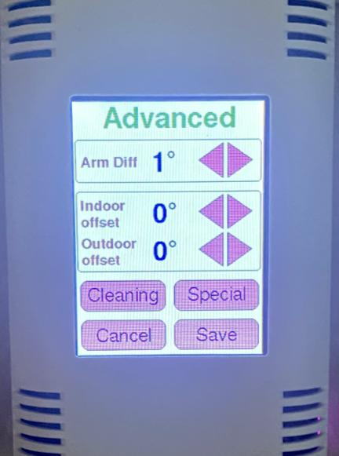
Figure 5: The Advanced Screen

Usually you will not need to change any of these settings. They are:
- Arm Diff - In the AUTO setting, if a maximum run time is set, once SmartVent runs for that amount of time, the thermostat says Wait Hot until the outdoor temperature exceeds the indoor temperature by this setting amount. Then, it resets the run time to 0 and returns to the Wait On arm state. You might change this if you want SmartVent to re-arm itself after reaching its run time limit once the outdoor and indoor temperature difference is some particular value of your choice.
- Indoor Offset - this is added to the measured indoor temperature to obtain the displayed indoor temperature. Normally this is set to 0, but if you find that the displayed indoor temperature is consistently off by one or two degrees in one direction, you might want to change this setting.
- Outdoor Offset - this works the same as Indoor Offset but it is for the outdoor temperature.

To change any setting, tap the triangular buttons to its right. The left-pointing triangle lowers the value and the right-pointing triangle raises it.

When finished, tap the Save button at the bottom to save the settings and make them permanent. Or, tap the Cancel button to discard your changes. Either button then returns you to the Main Screen.

Above the Save and Cancel buttons are two buttons labeled Cleaning and Special. If tapped, these take you to the corresponding screens.

Cleaning Screen
Tapping the Cleaning button on the Advanced Screen takes you to the Cleaning Screen (Figure 6). It has a simple purpose. If you want to clean the screen and start wiping it, you might accidentally make changes you don’t to make to thermostat settings. The Cleaning Screen ignores all taps on the screen, so you can clean it thoroughly without causing problems. When finished, simply wait half a minute or so, until the display goes dark. When you tap again it will be back to the Main Screen.

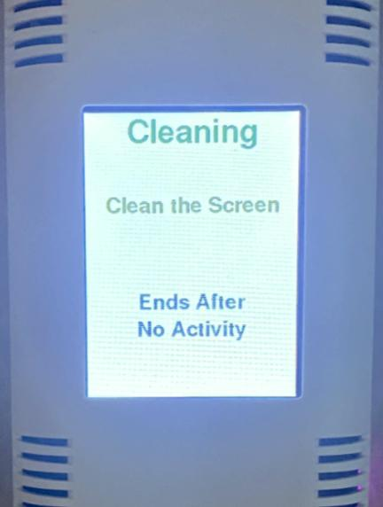
Figure 6: The Cleaning Screen

Special Screen
Tapping the Special button on the Advanced Screen takes you to the Special Screen (Figure 7). It has only three buttons, near the bottom. The Done button exits back to the Advanced Screen. The Calibrate button takes you to the Calibrate Screen, and the Debug button takes you to the Debug Screen. Most likely you won’t use these screens, although you might use the Calibrate Screen once only.

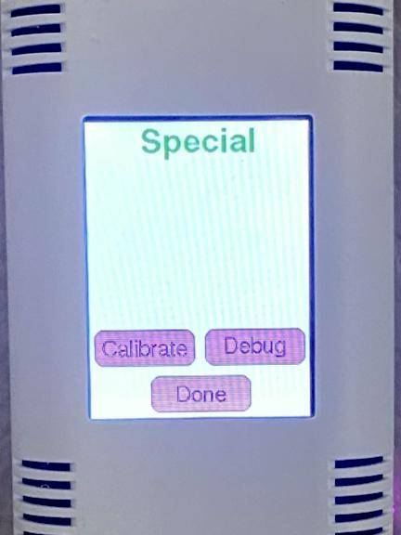
Figure 7: The Special Screen

Calibrate Screen
Tapping the Calibrate button on the Special Screen takes you to the Calibrate Screen (Figure 8).

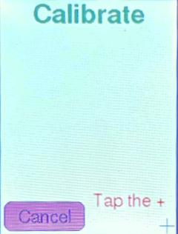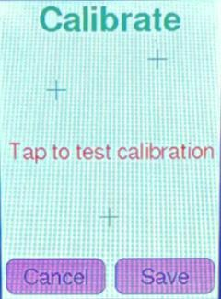
Figure 8: The three steps in the Calibrate Screen

The Calibrate Screen should be used if you notice that when you tap on the screen, it thinks you tapped in a slightly different location. This screen calibrates the relationship between where you touch the screen and where things actually are on the screen. If you need to do this at all, you should only need to do it one time.

The screen will show a blue “+” in the upper-left corner, with a message telling you to tap the “+”. Use the stylus to very accurately tap the center of the “+”. Then, another blue “+” will appear in the lower-right corner with another message. Again, tap the center of that second “+” as accurately as you can. Then, a message informs you that you can test the calibration by tapping anywhere. Tap in a few places and check to see if a green “+” appears precisely in the spot you tapped. If not, or if at any time you wish to cancel the calibration, tap the Cancel button at the bottom. If the green “+” symbols are at the right position, tap the Save button to save the new touchscreen calibration. Both Cancel and Save return you to the Special Screen.

Debug Screen
Tapping the Debug button on the Special Screen takes you to the Debug Screen (Figure 9).

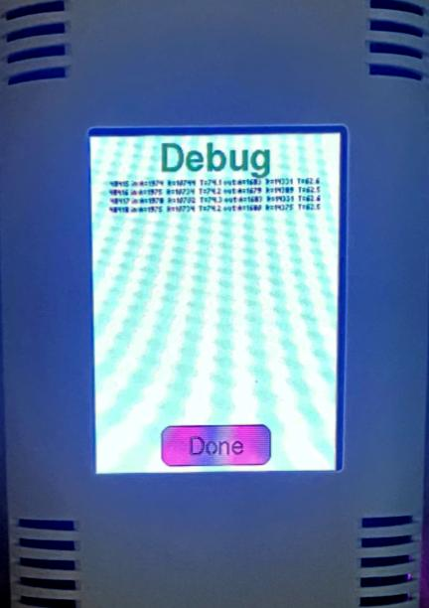
Figure 9: The Debug Screen

Most likely you will never use this screen. It is meant to show information that might be helpful to the DIYer who is building the thermostat. Currently, it shows the indoor and outdoor temperature readings every two seconds, along with special information such as circuit voltages and resistances of the thermistors used to measure temperatures. The DIYer might change the code to alter the screen contents to show something else of interest to him/her. Tap the Done button at the bottom of the screen to return to the Special Screen.

Troubleshooting
If the thermostat stops working, it is best if the DIYer that made it can troubleshoot it, but tips are given here.

Start by making sure the HVAC power is on. Snap the thermostat case off of its base on the wall and check that its fuse is intact, that the fuse holder isn’t bent, and the power switch is on. Also check that the 5-pin connector that connects it to the wall cable is firmly attached.

The next thing to do is to remove the 5-pin connector and bring the thermostat to a workbench where the wiring can be carefully inspected. It is common for a wire to come loose and need to be resoldered. It took a while to locate the place where it belonged. The wiring spreadsheet that is part of the thermostat project shows how the wires should be placed. Look for that spreadsheet on the hackster.io web site at the link given earlier.

It is possible that the Nano 33 IoT microcontroller (a square thing about 1” x 2” in size plugged into one corner of the thermostat) can burn out. If so, it is likely to be very hot to the touch. It can happen if a short occurs between the 24VAC and an I/O line to the microcontroller. That part can be ordered (e.g. on Amazon) and replaced.

If the display screen is cracked, a replacement screen can be ordered and replaced. It is (at this time, anyway) a standard component and you can find it too on Amazon. You might try replacing the screen if it stops working, produces irregular or wrong displays, or if the touchscreen stops working (it is integrated in with the touchscreen).

Another problem that can happen, also usually due to shorting out some wires, is that the power supply circuit on the thermostat case main board can fail. Look for something such as perhaps a blown-out capacitor that you can replace.

The entire thermostat case can be replaced, but that requires rewiring and rebuilding the circuitry on it.

If the indoor or outdoor temperature isn’t working, check the thermistor circuits. These have just three parts, a thermistor, a resistor in series with it, and a small capacitor across it. The capacitor is only there for reducing noise. The most likely problem will be a broken connection, so check the connections of those components carefully. The outdoor thermistor is located some distance away and has a lot of wire connecting it to the thermostat, so check for continuity through the cable. Thermistors are simply resistors with resistance that varies with temperature. These thermistors will have a resistance of somewhere around 10K ohms typically, so measure the resistance with an ohmmeter. If you find an open circuit, there is a problem. Similarly, a short circuit or very low resistance is also a problem.

If the indoor or outdoor temperature is displayed but is wrong, the corresponding thermistor is suspect. The DYI-er who builds the thermostat must ensure that he has determined the correct thermistor coefficients and entered those into the software code, else the temperature will be wrong. If something has gone wrong with a thermistor, it will need to be replaced. The indoor thermistor is soldered to the circuit board inside the thermostat, and looks like a little brown bead on long wires. The outdoor thermistor is located somewhere outside (perhaps on the outside of the A/C compressor, some of them look like a white plastic icicle about 3” long). Getting the correct replacement thermistor is critical, so try to obtain the thermistor specs from the DYI-er that built the thermostat. For example, you might have an EPCOS B57862S103F indoor thermistor and an NTC 10K type 2 thermistor with 10K ohms of resistance at 25°C for the outdoor thermistor.

If the SmartVent won’t turn on even though the thermostat says it is on, the problem might be that the relay is bad, or it could be that the transistor that turns it on is bad, or there is an open circuit somewhere along the transistor and relay circuit. Also remember that there is a connection at the EcoJay controller for turning on the SmartVent, and if that connection comes loose the SmartVent won’t work. If the SmartVent damper won’t open but the fan comes on, the problem probably lies with the damper motor.

The thermostat assembly instructions include instructions and code for testing different parts of the circuit. A competent DIYer can use these to test the device for problems of different kinds.

The DIYer that makes the SmartVent thermostat can always customize it, and one customization would be to use degrees Celsius instead.
Another customization is to change the colors of these lights.

